Features of Java
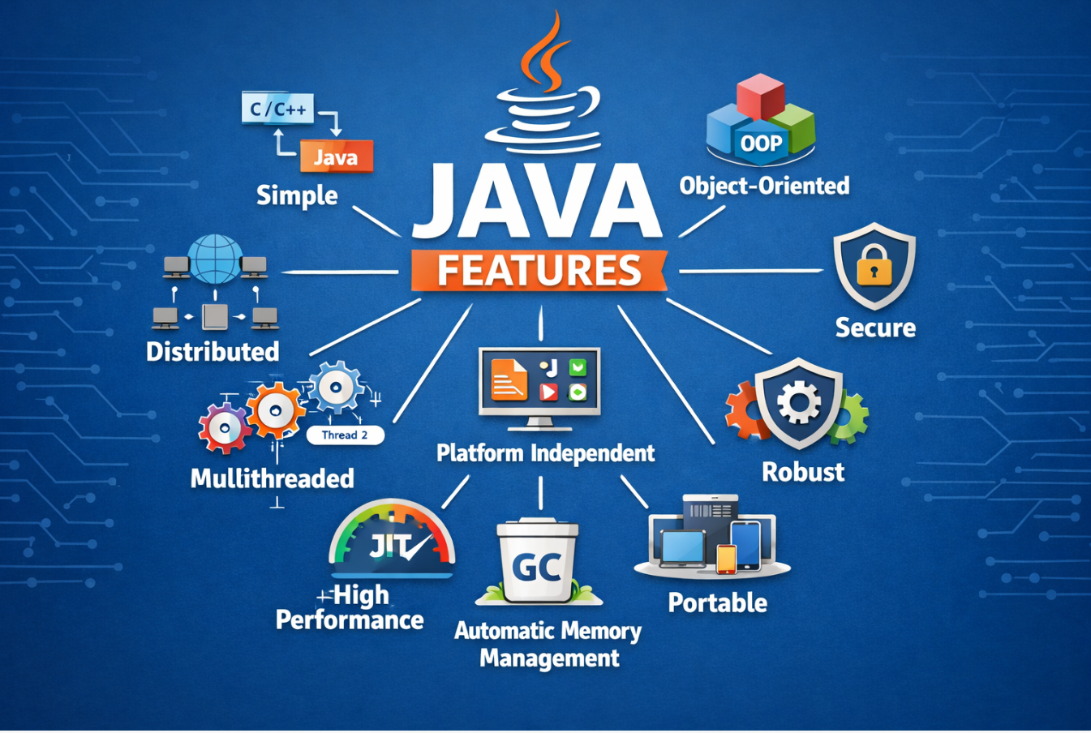

The Java programming language provides several powerful features that make it one of the most widely used languages in modern software development. Java was designed with important goals such as simplicity, reliability, portability, security, and high performance.
These features enable developers to create scalable, secure, and platform-independent applications that can run on different operating systems without modification. Because of these capabilities, Java is widely used in enterprise software, banking systems, Android applications, web applications, and cloud-based services.
The following are the most important features of Java
1.Simple
One of the most important features of Java is that it is simple and easy to learn compared to many other programming languages. Java was designed in such a way that programmers can easily understand its syntax and write programs with less complexity.
Java removed several complicated features that existed in older programming languages such as C++. These features included pointer arithmetic, operator overloading, and multiple inheritance through classes, which often made programs difficult to understand and maintain.
Because Java eliminates these complex features, the language becomes cleaner, safer, and easier for developers to use. The syntax of Java is also similar to C and C++, which makes it easier for programmers who already know those languages to learn Java quickly.
Another reason Java is considered simple is because it provides automatic memory management through garbage collection, which means programmers do not need to manually allocate and free memory as they do in languages like C.
Example of a simple Java program:
public class Hello {
public static void main(String[] args) {
System.out.println("Hello Java");
}
}
This program prints “Hello Java” on the screen. The clear structure and readable syntax of Java make it easy for beginners to understand and write programs efficiently.
Because of these characteristics, Java is widely used as a beginner-friendly programming language while still being powerful enough for large-scale software development.
2. Platform Independent
One of the most important features of Java is platform independence. In many traditional programming languages, programs are compiled directly into machine code that can run only on a specific operating system. However, Java follows a different approach.
When a Java program is compiled, the source code is converted into bytecode, which is an intermediate form of code that is independent of the underlying hardware and operating system. This bytecode is executed by the Java Virtual Machine (JVM).
Because JVM implementations exist for many operating systems such as Windows, Linux, and macOS, the same Java program can run on any system that has a JVM installed.
This concept is summarized by the famous Java slogan:
Write Once, Run Anywhere (WORA)
This feature significantly reduces development time because developers do not need to rewrite programs for different platforms.

- Diagram – Platform Independence

Java Source Code (.java)
↓
Java Compiler (javac)
↓
Bytecode (.class)
↓
Java Virtual Machine (JVM)
↓
Machine Code
↓
Program Execution

3. Object-Oriented
Java is a fully object-oriented programming language, which means that programs are built using objects and classes. Object-oriented programming helps organize software into reusable and modular components.
Object-oriented programming in Java is based on several important principles.
Classes
A class is a blueprint or template used to create objects. It defines the properties and behaviors that objects will have.
Example:
class Car {
String color;
int speed;
}

- Objects
An object is an instance of a class. It represents a real-world entity that contains both data and methods.
Example:
Car c1 = new Car();

- Encapsulation
Encapsulation refers to bundling data and methods inside a class and restricting direct access to some components. This improves data security and prevents unauthorized modification.

- Inheritance
Inheritance allows one class to inherit properties and behaviors from another class. This helps in code reuse and reduces duplication.
Example:
Vehicle
↑
Car

- Polymorphism
Polymorphism allows a method to behave differently depending on the object that calls it. It provides flexibility and improves program design.

- Abstraction
Abstraction hides internal implementation details and exposes only the essential features of an object.
This makes programs easier to use and understand.

4. Secure
Security is one of the major strengths of Java. Java was designed with built-in security mechanisms that protect systems from malicious code and unauthorized access.
Java provides several security features including:
Bytecode Verification
Before executing bytecode, the JVM verifies it to ensure that it follows Java’s safety rules.

- Class Loader Mechanism
The class loader controls how classes are loaded into memory. It prevents untrusted code from accessing sensitive system resources.

- Security Manager
Java provides a security manager that restricts operations such as file access, network access, and system-level operations.

- No Pointer Manipulation
Unlike languages such as C and C++, Java does not allow direct pointer manipulation. This reduces the risk of memory corruption and improves program security.
Because of these security mechanisms, Java is widely used in banking systems, financial applications, and enterprise-level software.

5. Robust
Java is considered a robust programming language, meaning it is designed to be reliable and resistant to errors.
Java achieves robustness through several mechanisms.
Automatic Garbage Collection
Java automatically manages memory through a process called garbage collection. The garbage collector identifies unused objects and removes them from memory, preventing memory leaks.

- Exception Handling
Java provides a powerful exception-handling mechanism that allows programs to detect and handle runtime errors.
Example:
try {
int a = 10 / 0;
}
catch(Exception e) {
System.out.println("Error handled");
}

- Strong Type Checking
Java uses strict type checking during compilation, which helps detect many programming errors before the program runs.
These features make Java applications stable and reliable.

6. Multithreaded
Java supports multithreading, which allows multiple tasks to execute simultaneously within a program.
A thread represents a separate path of execution. Using multiple threads allows programs to perform several tasks at the same time.
For example, a web browser can:
- Load web pages
- Download files
- Play videos
all simultaneously using different threads.
Example code:
class MyThread extends Thread {
public void run() {
System.out.println("Thread running");
}
}
Multithreading improves application performance and responsiveness, especially in large systems.

7. Portable
One of the important features of Java is portability. Portability means that a Java program can be easily transferred and executed on different computer systems without making significant changes to the code.
In many traditional programming languages, programs are compiled into machine-specific code, which means the program can only run on the system for which it was compiled. If the program needs to run on another operating system or hardware architecture, it must be recompiled or modified.
Java solves this problem by compiling source code into an intermediate format called bytecode instead of directly generating machine code. This bytecode is independent of the underlying hardware and operating system.
The bytecode is executed by the Java Virtual Machine (JVM), which acts as a translator between the Java program and the operating system. Because JVM implementations exist for different platforms such as Windows, Linux, and macOS, the same Java bytecode can run on any system that has a compatible JVM installed.
This architecture makes Java highly portable and allows programs to run on multiple systems without modification. Developers can write a program once and run it on many different platforms, which significantly reduces development and maintenance effort.
- Diagram – Portability in Java
Java Source Code (.java)
↓
Java Compiler (javac)
↓
Bytecode (.class)
↓
Java Virtual Machine (JVM)
↓
Runs on Any Operating System
(Windows / Linux / macOS)
Java Features Overview Diagram

Java Features
┌─────────────────────────┐
│ Simple │
└────────────┬────────────┘
│
┌────────────▼────────────┐
│ Object-Oriented │
└────────────┬────────────┘
│
┌────────────▼────────────┐
│ Platform Independent │
└────────────┬────────────┘
│
┌────────────▼────────────┐
│ Secure │
└────────────┬────────────┘
│
┌────────────▼────────────┐
│ Robust │
└────────────┬────────────┘
│
┌────────────▼────────────┐
│ Multithreaded │
└────────────┬────────────┘
│
┌────────────▼────────────┐
│ Portable │
└─────────────────────────┘

